Talia Cavalline

4869 Westfield Drive, Manlius, NY, 13104

# SKILLS

Adobe Cloud Media Editing, Final Cut Pro Editing, CPR/AED, Social Media Content, Reporting and Writing Techniques

# AWARDS

University of South Carolina President’s List Spring 2023. University of South Carolina Dean’s List Fall 2023 and Spring 2024.

# EDUCATION

#### Fayetteville Manlius High School, Manlius, NY

*NYS Advanced Regents Diploma*: Sep. 2018 - June 2022

Student Council AV Director, Model United Nations Director for the Economic and Social Council, Varsity Volleyball Captain

#### University of South Carolina - Columbia, SC

*B.A in Broadcast Journalism with Sports Media*

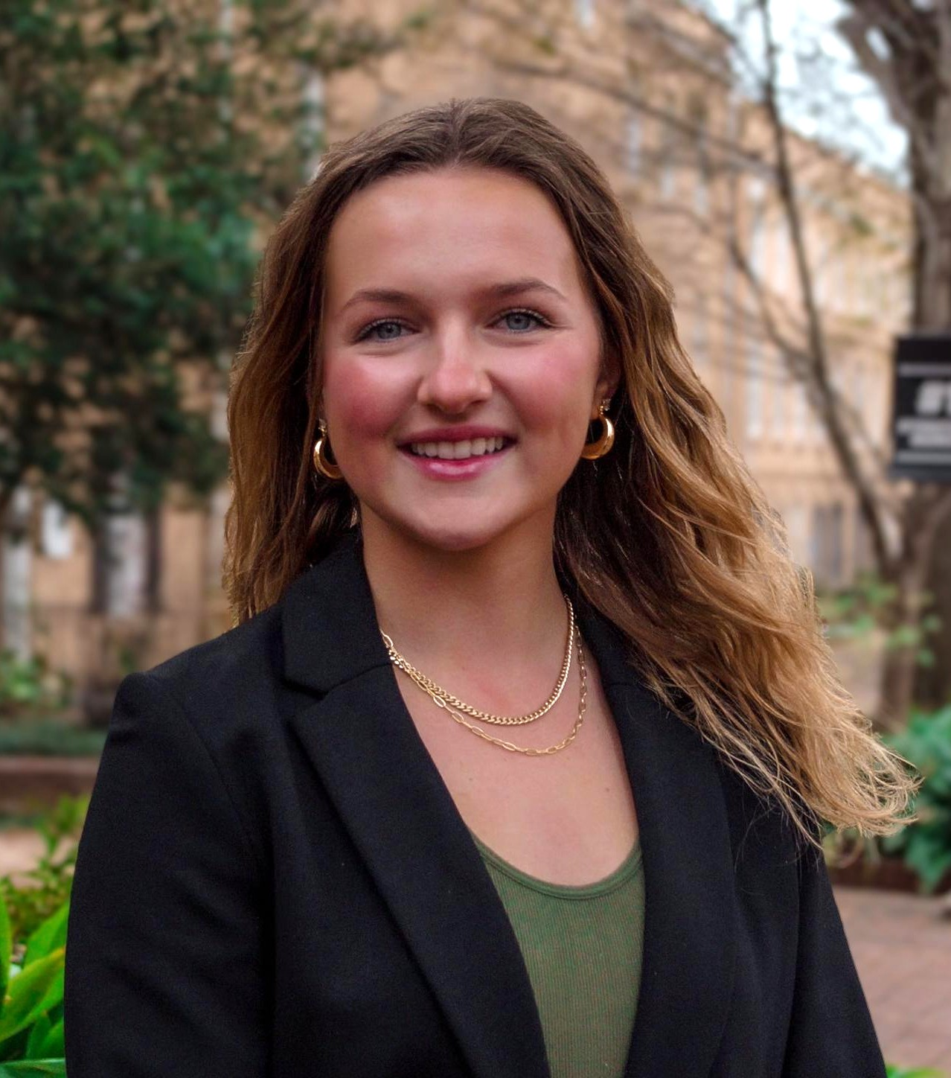Minor in Sport and Entertainment Management, Member of Beta Delta Chapter of Delta Zeta, Expected to graduate in December 2025

## [talcav22@gmail.com](mailto:talcav22@gmail.com) [taliawc@email.sc.edu](mailto:taliawc@email.sc.edu)

[Talia Cavalline Linked In](https://www.linkedin.com/in/talia-cavalline-233b271b9/) [https://www.taliacavalline.com/](http://www.taliacavalline.com/)

## (315) 481-9059

**EXPERIENCE**

### Gamecock Athletics, Columbia, SC

*Internal Communications Intern:* January 2023 - Present

Complete tasks to assist with materials used in Gamecock Athletics social media pages and games for all University of South Carolina athletic events.

Responsibilities: Attend athletic events as an assistant for Athletics SID’s, attend weekly office hours to assist with different tasks, use Adobe Cloud software to edit/take photos and videos, create graphics, assist in running various social media accounts.

### Syracuse Spartans NYCBL, Syracuse, NY

*Sports Media Intern*: May 2024 - August 2024

Produced and facilitated all social media content via X, Instagram, and Facebook for the Syracuse Spartan’s 36 game season.

Responsibilities: Created in game graphics with Adobe Indesign, prepared/anchored post game interviews with players and coaches, communicate with staff, team, and photographers daily.

### The Daily Diner, Manlius, NY

*Server*: May 2023 - Present

Work to take orders and serve customers in timely manner.

Responsibilities: Clean restaurant before and after shift, communicate with coworkers concerning side work, create friendly atmosphere.

### Papa Gallo Mexican Restaurant, Fayetteville, NY

*Server*: August 2020 - December 2023

Work to take orders and serve customers in timely manner.

Responsibilities: Clean restaurant before and after shift, communicate with coworkers concerning side work, create friendly atmosphere.

### Four Seasons Winter Resort, Fayetteville, NY

*Ski Instructor*: November 2020 - April 2021

Worked with children and adults on beginners ski and snowboard mountain.

Responsibilities: teach customers the basic skills necessary to ski, taught ski safety rules to keep everyone safe/alert, communicate with coworkers concerning lesson plans.